Distruption:  
1. Need to have a threat response

2. Need to have an opportunity business

Nestle example: Probiotics  
Fujifilm example : Print & medical digital

Nescafe – increasing shelf life, US army

Coca cola, luck stripes, Marlboro – US army

Consumer behavior changes – Disruption in 70% to nestle

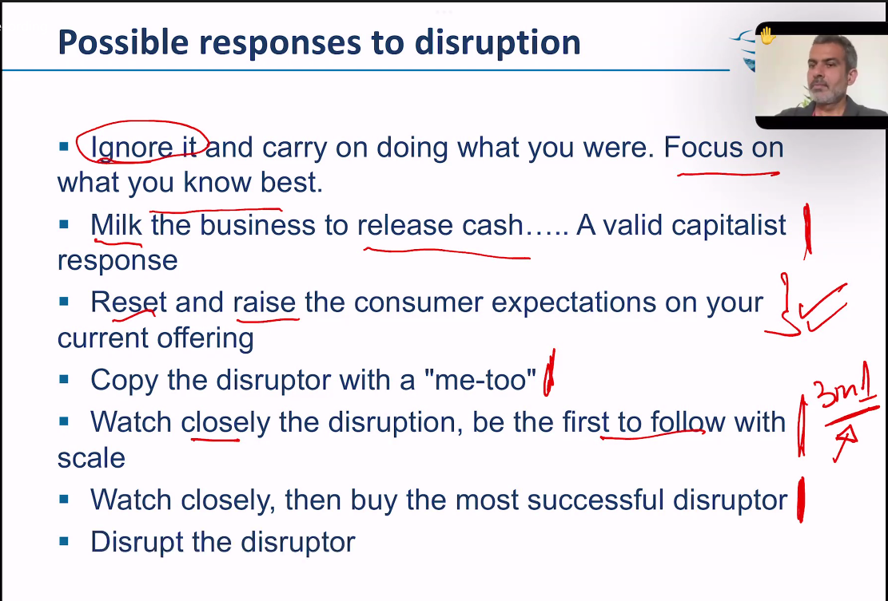

13 days movie before next session

Nvidia story

